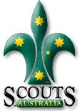
You’re coming to….
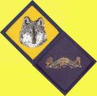
Gold Camp IV!

Rowallan Scout Camp
Riddells Creek
7pm, Fri 15th- 4:15pm, Sun 17th March, 2013

Welcome to Gold Camp IV! It’s a fantastic camp only for older Cubs – you’ll learn more about how to go out and earn your Grey Wolf Award, get a chance to earn a Level 2 Bushcraft Badge and experience a bit of what it’ll be like to be in Scouts! You’ll be camping with Cubs and Leaders from Rosanna, and other Cub Packs from across Melbourne and Victoria.

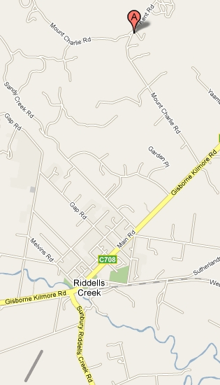
Location: Rowallan Scout Camp, Kent Rd, Riddells Creek, Vic
About it: We’ll be camping in tents, eating our meals (most of which you CUBS will cook!) and will be having tons of fun while we learn some great stuff. We’ll be right next to the Pack Holiday Centre, with full toilet / shower facilities and full shelter if the weather gets too rough.
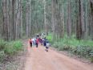
Doing? The Grey Wolf is the highest award in Cubs and has to be done by the Cubs themselves… this Camp aims to help you learn what to do and experiment for yourself – even going on a 2 hour practice hike! – so you can go home and be more confident in earning your Grey Wolf. ALSO you’ll get the chance to earn one of the Level 2 Badges you’ll need for the Grey Wolf AND you’ll try some Scout stuff – like cooking in Patrols, building stuff and having fun with it, and more! Don’t miss it!
Leaders: Leaders from all Packs attending.
Take: Your Kit list and Health Form is attached.
Contact: Your contact at the camp will be your attending Cub Leader

